Six knowledge points:
1 What is the role of Architectural design?
- is concerned with understanding how a software system should be organized and designing the overall structure of that system.
- is the critical link between design and requirements engineering, as it identifies the main structural components in a system and the relationships between them.
- The output of the architectural design process is an architectural model that describes how the system is organized as a set of communicating components.

2. Please analyze the following architecture of a packing robot control system.
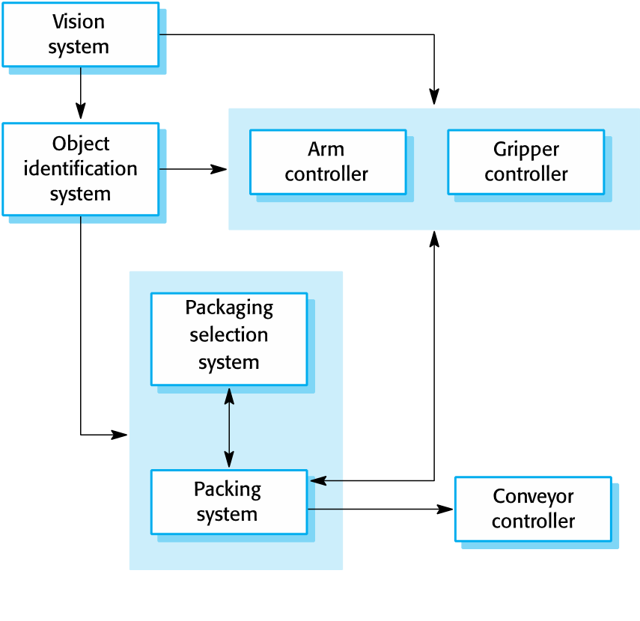
- The robot uses the vision system to pick out objects on a conveyor, identify the type of object and select the right kind of packaging.
- It packs the object and places it on another conveyor.

3. Please describe 8 common decisions for Architectural design.

4. What are the five Architecture and system characteristics?
- Performance
- Localize critical operations and minimize communications. Use large rather than fine-grain components.
- Security
- Use a layered architecture with critical assets in the inner layers.
- Safety
- Localize safety-critical features in a small number of sub-systems.
- Availability
- Include redundant components and mechanisms for fault tolerance.
- Maintainability
- Use fine-grain, replaceable components.

5. Please describe four kinds of Architectural views?
Architectural model only shows one view or perspective of the system.
- It might show how a system is decomposed into modules, how the run-time processes interact or the different ways in which system components are distributed across a network.
- For both design and documentation, you usually need to present multiple views of the software architecture.

6. Please give some examples for Architectural patterns including MVC, Layered architecture, Repository architecture, Client-server architecture, the pipe and filter pattern.
- The Model-View-Controller (MVC) pattern
- It separates the application logic from the user interface and the control between the user interface and the application logic.

DemoController

DemoView
DemoModel

PaintPanel

- Layered architecture
- Used to model the interfacing of sub-systems.
- Organizes the system into a set of layers (or abstract machines) each of which provide a set of services.
- Supports the incremental development of sub-systems in different layers. When a layer interface changes, only the adjacent layer is affected.
User Interface

User interface management Authentication and authorization

Core business logic/application functionality system utilities

System support (OS, database etc

- Repository architecture
- Sub-systems must exchange data. This may be done in two ways:
- Shared data is held in a central database or repository and may be accessed by all sub-systems;
- Each sub-system maintains its own database and passes data explicitly to other sub-systems.
- When large amounts of data are to be shared, the repository model of sharing is most commonly used a this is an efficient data sharing mechanism.

UML editors
Code generators

Java editor
Project Repository
Design translator
Python editor

Design analyzer
Report generator

- Client-server architecture
- Distributed system model which shows how data and processing is distributed across a range of components.
- Can be implemented on a single computer.
- Set of stand-alone servers which provide specific services such as printing, data management, etc.
- Set of clients which call on these services.
- Network which allows clients to access servers.

Client 1
Client 3
Client 4
Client 2

Internet

Picture server
Catalog server
Video server
Web server

- The pipe and filter pattern
- Functional transformations process their inputs to produce outputs.
- May be referred to as a pipe and filter model (as in UNIX shell).
- Variants of this approach are very common. When transformations are sequential, this is a batch sequential model which is extensively used in data processing systems.
- Not really suitable for interactive systems.

Receipts
Issue receipts

Identify payments

Payments
Issue payments reminder
Find payments due

